# ITIL Investigation

The client has expressed interest in the new system following ITIL principles to allow the IS department to eventually move to an ITIL framework approach of working. Therefore the ITIL practises have been investigated, allowing the requirements of the new system to reflect this and discussions with the client.

**ITIL Introduction**

Information Technology Infrastructure Library (ITIL) is a defined set of practises for IT Service Management (ITSM). ITIL was established in the early 1990s when there was a growing need for IT service management, which led to a series of books that documented the approach being developed, since then it has been updated and is now on the third version of ITIL.

ITIL is very well recognised and is successful, often down to the selection of best practises

The core guidance is on the following topics:

* Service strategy – Guidance is given on the principles that underlie service management, which allows for the organisations to set objectives relating to the performance
* Service design – Plans to create and change services and service management processes.
* Service transition – Manage the transactions of a new or changed services.
* Service operation – This gives guidance regarding the day to day operations of services and service management processes.
* Continual service improvement – This is the activities that are included in the overall service lifecycle.

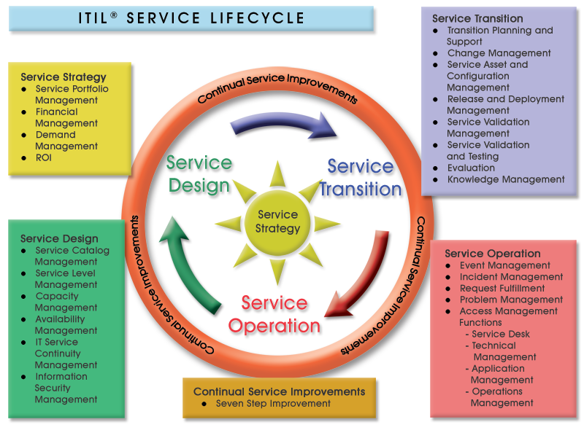

**Service Operation**

Service operation is a key area of the ITIL practises, where there is a high business value and customers in particular can see value. This section focusses on the service desk, technical management, IT operations management and application management.

This investigation is primarily looking at the service desk, to allow the new system for Numatic to be developed in a way that conforms to the principles. The service desk will be…. although, it is noted that in order for the service desk to be successful the staff using it, must provide a good service, provide a timely and professional service. Meaning business can continue to run in an effective manner, in order to allow this staff will need appropriate training as part of the implementation phase of the project.

There are many different processes that should be included in a service desk, these are:

* Event Management – The monitoring of events through IT infrastructure.
* Incident Management – Looking at restoring a disruption to services to users as quickly as possible.
* Problem Management – This is focused on root cause analysis of events and incidents, to allow causes to be resolved.
* Request Fulfilment – The process of managing customer’s requests.
* Access Management – The process of granting users permission to certain services.

These have been further investigated below to help ensure that all information is collected prior to the design stage of development to ensure it can be discussed during requirement elicitation of the system.

Incident Management:

This is perhaps the most common part of a service desk and will be used frequently at Numatic, with over 400 PCs on-site and the manufacturing that is heavily reliant upon IT, there are many end users that many report incidents to the IS Helpdesk- primarily by phone or email. In incident is classed as ‘an unplanned interruption to an IT service’ and the main aim is to restore normal operation as soon as possible, to reduce disruption.

Some examples of incidents include:

* Printer or hardware faults,
* Systems down,
* Errors occurring in applications,
* Disk space full

Principles of incident management:

* Timescales - Every incident must have an agreed timescale, based on priority of incident and SLAs. These should be automatic.
* Incident Models - Used to treat recurring incidents with a standard procedure.
* Status tracking - All incidents should be tracked throughout their lifecycle. Statuses of incidents will be; open, in progress, resolved, closed.

Relevant information must be included when logging incidents, this might include:

|  |  |
| --- | --- |
| Unique ID |  |
| Categorisation | Ensures the type of incident is recorded |
| Urgency | Urgency and impact can be used together to allow a priority of an incident to be determined. Example coding below: |
| Impact |
| Prioritisation |
| Date/time recorded |  |
| Name of person recording incident |  |
| End user details |  |
| Description of symptoms |  |
| Incident status | open, in progress, resolved, closed |
| Allocated analyst or support group |  |
| Related problem/ known error |  |
| Activities undertaken to resolve incident |  |
| Resolution date and time |  |
| Closed category |  |
| Closure date and time |  |

Request Fulfilment:

A service request is a request made to the IT department by users, these are usually small and frequent requests. Examples of these requests include:

* Installing additional software
* Request to change password
* Request for workstation move
* Request for information

Relevant information must be included when logging requests, this might include:

|  |  |
| --- | --- |
| Unique ID |  |
| Categorisation | Categorise the request by the activity that is being undertaken. E.g. Password reset, desktop installation. |
| Urgency | Urgency and impact can be used together to allow a priority of an incident to be determined. Example coding below: |
| Impact |
| Prioritisation |
| Date/time recorded |  |
| Name of person recording incident |  |
| End user details |  |
| Description of request |  |
| Request authorisation | Ensure the request is authorised before it is undertaken. |
| Request status |  |
| Allocated analyst or support group |  |
| Fulfilment date and time |  |
| Closure date and time |  |

Problem Management:

The purpose of problem management is to manage all problems leading to identifying the underlying errors in the IT infasture, once the underlying problems are fixed it is hoped to reduce the number of related incidents. These technical issues can exist without nessicarily effecting the users, examples of these problems include:

* Erratic disk space
* Slow network
* Applications crashing intermittently

These problems are different from incidents and will usually be assinged to more senior members of the support team, that are 2nd/ 3rd line support.

Relevant information must be included when logging problems, this might include:

|  |  |
| --- | --- |
| Unique ID |  |
| User Details |  |
| Service details |  |
| Equipment details |  |
| Prioritisation |  |
| Urgency |  |
| Impact |  |
| Name of person recording incident |  |
| Date/time recorded |  |
| Categorisation | Problems will be categorised in the same way as incidents. |
| Incident description |  |
| Incident record numbers/ cross references |  |
| Diagnostic and attempted recovery actions taken. |  |
| Allocated analyst or support group |  |
| Resolved date and time |  |
| Closure date and time |  |

Access Management:

The process of granting the users the permissions to a particular service providing they have adequate level of access. Examples of this include:

* Removing / granting access when users change roles or jobs
* Giving a particular user or user group permissions to a service

Requests for changes in access will be primarily done through a service request via the service desk.

Event Management:

Event management is about knowing the state of the IT infrastructure, which detects and alerts if there are any deviations from expected behaviour. Examples of these events, which may need investigating are:

* Failed login with incorrect password
* Completion time of transactions taking unacceptable time
* Server memory approaching highest acceptable performance level

These events will often be logged and notifications will alert staff members if required, these events should be logged along with any additional actions taken in an event management tool. In some instances an event may be handled in an incident, problem or service request; these will be logged through the system.

**Current System**

As explained in the analysis of the current system document, Numatic’s current system has no method of identifying the type of ticket, meaning all tickets are classed as incidents. This often becomes problematic due to the number of tickets open, many of these are not actually incidents and are more often service requests and problems. This means there is no way of narrowing down the view, to only see incidents or other types of tickets, it can also confuse analysts with the most important tasks that are required to be done. If an ITIL approach was taken many of these problems see with the current system would be reduced and it would also allow other parts of ITIL to be followed, thus improving the efficiency of the department.

**New System**

Numatic would like their whole IS department to follow the ITIL methodology, whilst much of the ITIL practises cannot be solved by just implementing a new system, it is hoped a new system will help pave the way for the practises to put in place. Many of the ITIL practises will take a long time to be implemented throughout the department and may mean a change in procedures and way of working.